Capstone Project **Arwa Ibrahim**

Machine Learning Engineer Nanodegree  **December 9, 2019**

##### Definition

### **Project Overview**

Face verification in unconstrained conditions has obtained increasing attention and encouraging progress in recent years. Biologists find that human facial appearance is an important cue for genetic similarity measurement. Motivated by this finding and related applications such as social media analysis, missing children searching, **kinship verification** through facial image analysis has attracted more and more attention over the past few years.

Automatic kinship verification using facial images has several applications such as locating relatives in public databases, determining the kin of a victim or suspect by law enforcement agencies, screening asylum applications where kinship relationships are to be determined, organizing and resolving identities in photo albums. There are several security aspects of kinship verification where kin of people identified as a security threat can be identified by using an automatic kinship verification framework. Automatically determining kinship information can also be used to boost automatic face recognition capabilities by utilizing the kinship characteristics as soft biometric.

A fair question to ask is if so applicable, why is visual kinship recognition technology not found, or even prototyped, in real-world products? Reasons for this are two-fold:

1. Image datasets for kinship recognition tasks do not capture nor reflect the true data distributions of the families in the world. Furthermore, other collections are small in size.
2. Kin-based relationships are less discriminant than other, more conventional face-based problems, as there exist many hidden factors that affect the facial appearances among different family members.

### **Problem Statement**

In this project the focus is on trying some of the proposed solutions for the following problems:

* The kinship verification problem (one_to_one):

1. Using a pre-trained transfer learning model such as VGG19, ResNet50, Inception and Xception.
2. Trying an auto-encoder based method such as SDAE, DBN and fcDBN.

* The family classification (one_to_many) using the official pre_trained VGG model.

### **1.3 Metrics**

The evaluation metric chosen is the AUC - ROC curve. AUC - ROC curve is a performance measurement for classification problem at various thresholds settings. Where ROC is a probability curve and AUC represents degree or measure of separability. It tells how much model is capable of distinguishing between classes. Higher the AUC, better the model is at predicting 0s (non-related) as 0s and 1s (totally related) as 1s.

##### Analysis

### **Data Exploration**

The project works with the version of the FIW database provided in the FIW kaggle competition. The decision of working with a competition version instead of the original is taken in order to test the model and compare it with some of already proposed and tested models.

The kaggle database consists of 4 files as follows: train databases, test database, and 2 csv files one of them contains training pairs and the other for test pairs.

The train_relationships.csv file consists of 3598 data records each record represent a pair of images. So it is consists of 2 columns labeled as **p1** (the first image code) and **p2** (the second image code).

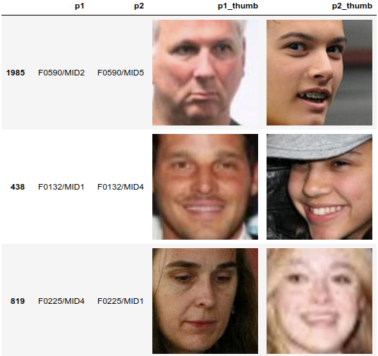

**Fig. 1** A sample pairs of photos. Note that the p1_thumb and p2_thumb

are generated they don’t exist in the real file.

### **Exploratory Visualization**

While exploring the data some of the samples have a None value after more exploration it founded that some of records have an invalid locations that not exist. Therefore, the data cleansing step is needed.

Data cleansing is done using a dictionary to keep all of the photos path. Then we loop on the database and exclude all the records that have one or more invalid photo path.

analysis3.1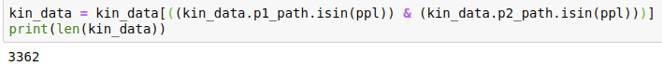

**Fig. 2** Shows the number of the valid paths which is 2316, a sample of the dictionary content, the filtering step and finally the size of the database after the data cleansing step.

For data analysis step, the existing families have codes which ranges from F0000 to F1000 so we will deal with it as subsets of 100 and calculate the number of occurrence in of it in the training pairs. Next the actual number of families out from each subset is calculated. The last thing is to calculate the number of members in each subset.

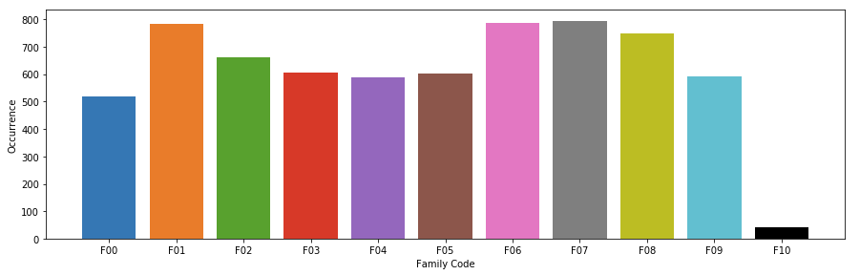

**Fig. 3** Shows the number of occurrence in the training pairs of the families that begins with one of the family codes presented on the x-axis. From the figure we can exclude that the families that have the most number of pairs are those with F01 or F06 or F07 as a family sub-code and the families that have least number of occurrence are those with F10 as a family sub-code.

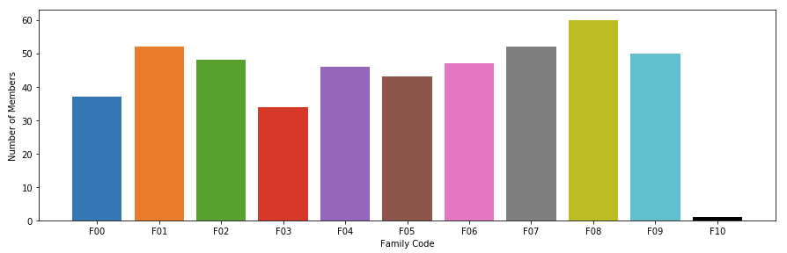

**Fig. 4** Shows the number of members of each family in the database according to the family codes presented on the x-axis. From the figure we can exclude that the families that have most number of members are those with F08 or F07 or F01 as a family sub-code and the families that have least number of members are those with F10 as a family sub-code.

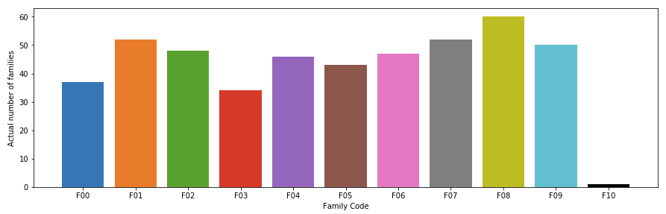

**Fig. 5** Shows the actual number of families in the database that begins with one of the family codes presented on the x-axis. From the figure we can exclude that most of the families have F08 or F07 or F01 or F09 as a family sub-code and only one family with the F10 sub-code.

### **Algorithms and Techniques**

### **Benchmark**

The used benchmark model is originally proposed by authors of the 1st place solution in the FIW2017 competition proposed KinNet, a fine-to-coarse deep metric learning framework for kinship verification. In the framework, the authors transferred knowledge from the large-scale-data-driven face recognition task by pre-training the network with massive data for face recognition. Then, the network was fine-tuned to find a metric space where kin-related peoples are discriminant.

##### Methodology

(approx. 3~5 pages)

### **3.1 Data Preprocessing**

### **3.2 Implementation**

### **3.3 Refinement**

##### Results

(approx. 2~3 pages)

### **4.1 Model Evaluation and Validation**

### **4.2 Justification**

##### Conclusion

### **5.1 Free-Form Visualization**

### **5.2 Reflection**

### **5.3 Improvement**

In this project, the focus were on trying the deep-learning based methods, discover the effect of previous face recognition, and the effect of previous facial points detection. However, while working two interesting things are discovered that may affect the overall model accuracy.

Although this project worked on some of important features that affect the accuracy, more accuracy advancement can be achieved by developing the following:

* In building databases for kinship verification process, often different individuals’ images have been cropped from larger family photos. While this is a good way to find people in the same family it also builds in another clue – a bias that people from the same photo are related. This has been overlooked as a potential issue, as it is far easier to identify whether two face images are from the same original photo than it is to determine if they are kin. So, this ‘from same photograph’ (FSP) signal can be used to achieve results comparable to the state of the art [13].
* Most of the methods proposed so far are to verify kinship from images. So, it’s interesting to try a method using facial dynamics to verify kinship from videos. The followed approach is that we all know people who do not look like their parents, until they smile. Furthermore, findings of [14] shows that the appearance of spontaneous facial expressions of born-blind people and their sighted relatives are similar. However, the resemblance between facial expressions depends not only on the appearance of the expression but also on its dynamics, as each expression is created by a combination of voluntary and involuntary muscle movements [15].

##### References

[1] R. Fang, K. D. Tang, N. Snavely, and T. Chen, “Towards computational models of kinship verification,” in IEEE International Conference on Image Processing, 2010.

[2]

[3]

[4]

[5]

[6]

[7]

[8]

[9]

[10]

[11]

[12]

[13] Mitchell Dawson, Andrew Zisserman, and Christoffer Nellåker. “From Same Photo: Cheating on Visual Kinship Challenges”. Computer Vision – ACCV, 2018.

[14] G. Peleg, G. Katzir, O. Peleg, M. Kamara, L. Brodsky, H. Hel-Or, D. Keren, and E. Nevo. “Hereditary family signature of facial expression”. Proceedings of the National Academy of Sciences, 2006.

[15] Hamdi Dibeklioglu, Albert Ali Salah, and Theo Gevers. “Like Father, Like Son: Facial Expression Dynamics for Kinship Verification”. IEEE International Conference on Computer Vision (ICCV), 2013.

[16]

[17]

[18]

[19]

[20]

[21]

[22]

[23]

[24]

[25]

[26]

[27]

[28]

[29]

[30]